
Medellin Night Clubs
(for bars see the restaurant guide)
Medellin Apartments Night Life Guide
www.ParadiseRealtyMedellin.com

Right now I just have discotecas (night clubs) from 4 areas listed below, with a general description of areas to go in Bello. Just to be clear, these are regular dance clubs. Night clubs here in Medellin Colombia does not refer to adult entertainment. If you have a good place to add to this list just email me. This is a work in progress. I have focused this list on clubs in or around El Poblado, Medellin.
1) Parque Lleras (Lleras Park):
Also known as the Zona Rosa of Medellin. This is definitely the spot that has the most bar restaurant establishments in Medellin. It’s a nice place to walk around, people watch, and all restaurants make a good income off of selling bottles and drinks. There only about 10 discotecas in this area, but worth checking out. This is also a very safe area to tour the night clubs.

2) Las Palmas:
(5 MINUTES IN TAXI FROM PARQUE LLERAS) This is a favorite spot for many locals to hit on Thursday and Saturday nights. They are open on Friday as well but it seems to be busiest mostly on Thursday, and Secondly on Saturday. Thursday nights Babylonia is recommended. This is a very safe area in El Poblado.

3) BARRIO COLOMBIA
(A HOT SPOT FOR NIGHT CLUBS JUST NORTH, and down hill from EL POBLADO)
Just a few minutes in taxi from Parque Lleras. Located in a commercial warehouse district next to El Poblado. Catch a cab here at night, its on a safe side of town located next to El Poblado.

4) SUPER CLUB DISTRICT
(Medellin Autopista / Highway)
just south of El Poblado
Located on the highway south of the El Poblado exit about 5 minutes once you are on the highway.

Bello Night Clubs:
This area is far away and recommended for people going out with locals, groups, or Medellin veterans who speak Spanish. Bello is its own municipality North of Medellin. It averages about 14,000 pesos or 7 bucks to get there or back.
There are 4 areas in Bello where night clubs are located. They are 1) Barrio Obrero, 2) La Choza, 3) Prado (not prado en el centro) and 4) Niquia (behind Exito).

Helpful Hint – CHEAP LOCK SMITH: Here is a cheap lock smith for when you loose your keys: If you get locked out when your drunk or just loose your keys the cheapest lock smith we have found in El Poblado is Llaves El Parque. We have used them many times for our clients. Just call 302-6677, 331-2356, or their cell phones are 300-602-3260, or 314-673-1014. Just about $7.50, or 15,000 mil to open your door.

Parque Lleras Area
Moon

Address: Calle 10a #38-21 (2 blocks from Parque Lleras)
Telephone: 311-4000
Moon Video on You Tube
http://www.youtube.com/watch?v=T-2P4uBa8TQ

Agua Panela  Zona Rosa (2 blocks from Lleras)  Calle 10 A no 40-68  No Cover  * Verify your bill is correct at night time, waiters like to test if you’re a gringo that knows how to count pesos, (like me). Small discoteca but fun  2 68 49 95 | 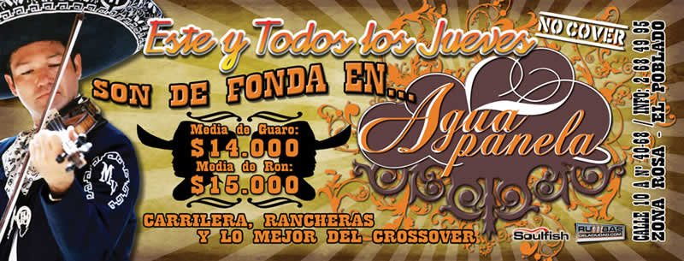

B Lounge
Good on Wednesday Night.
1 block up hill from Dominos Pizza on Calle 10, take a left and its ½ block over. Located between Calle 10, and Calle 10a. Just 1 block up from Tiger Paw Hostel and Dominos Pizza
Usually Jammed packed like sardines on Wednesday
Folia Club
JUST CLOSED … A NEW CLUB IS LOCATED HERE NOW
Calle 10 No. 40-07 (Parque Lleras)
Zona Rosa El Poblado
Info 266-26 07 - 300 292 86 79


OZ Triada
Address: Cra. 38 N. 8 – 20 (Parque Lleras)
Telephone: 311 57 81
Prices between: $6.000 - $650.000.
Comments: Its decoration is like a Night club from Europe.
All type of Music like Electronic and Dance.
OZ is located on the second floor of Triada
Las Palmas
(5 MINUTES IN TAXI FROM PARQUE LLERAS)
this neighborhood is located up hill and in the north part of El Poblado

Babylon  Las Palmas  Women free until 10:30  Free Drinks Thursday, Cover 20,000  This place is a favorite for guys looking for single women in the 18-25 age range.  Open until 4am  381 8169  http://www.mundou.com | 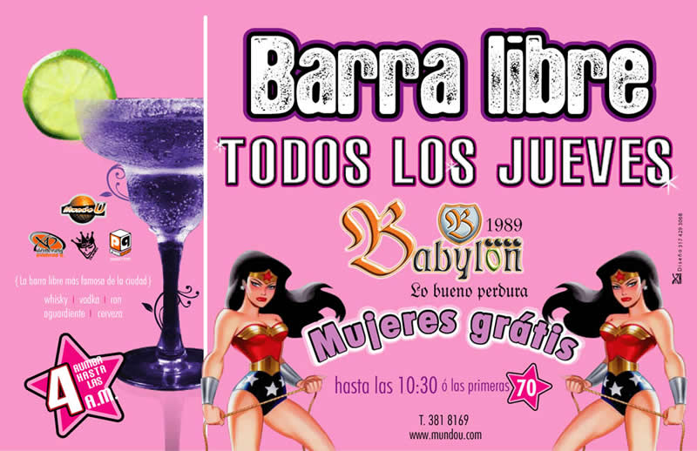

http://medellin.pegateya.com/design/pegateya/index.php

Canalón
Carrera 40 No 75 sur-25
Teléfono: 2887408
Cover: $ 10.000 pesos. Prices between $ 35.000 and 150.000 pesos.
Thursday to Saturday: 7:00 p.m. to 3:00 a.m.
Capacity: 700 people.
Live shows, singers and dancers.
DJs and contests.
Music: Crossover
Circus
Cover: $ 10.000 pesos. Prices between: $ 35.000 and 150.000 pesos.
Different Music everyday: Wednesday: Romantic Music.
Thursday: Salsa music and Regetton.
Friday: electronic music. Saturday: Crossover.
**located across the street from La Casa and Babylon

Palmitas
Address: Cra. 38 N. 26 – 41 (In Las Palmas)
Telephone: 381 51 04
Great Live Latin Dance shows
Salsa, Merengue

BARRIO COLOMBIA
(A HOT SPOT FOR NIGHT CLUBS JUST NORTH OF EL POBLADO)
3 MINUTES IN TAXI FROM PARQUE LLERAS

DC10  Barrio Colombia (just north of El Poblado)  Cll 25A No 43B 199  Live Music  Info 232-2313  http://www.dc10envio.com  Part of an airplane is sticking out of the club | 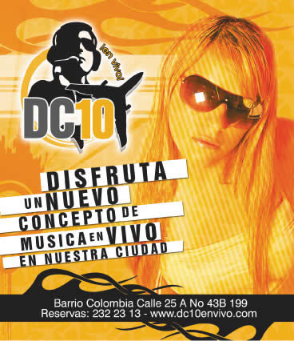

Kukaramakara Club Medellín
Carrera 43G No. 25A-58
Barrio Colombia
http://www.kukaramakara.com/menuanimadomedellin.html
RESERVAS 232-8390
live music, food, drinks

Guadalupana
www.Guadalupana.com
A fun restaurant bar
in Barrio Colombia

Guam Bar
K2 via Las Palmas (Las Palmas)
Info 266-1116
http://www.discotecaGuamBar.com

The Pablo Escobar Tour:
Looking for a fun tour, check out the Pablo Escobar tour. Learn where Pablo Escobar was born, where he died, and check out which buildings he owned in Medellin. You can also see the prison he remodeled and if you have time you can see his rance, Hacienda Napolis, it is a few hour drive out from Medellin

SUPER CLUB DISCTRICT
(Medellin Autopista / Highway)
just south of El Poblado
These 3 clubs are the largest in Medellin. They are also the most expensive.
Mango's Discoteca
Address: Cra 42 # 77 A 151 (Autopista Sur)
Telephone: 277 61 23
Prices between: $50.000 - $1.200.000
Comments: Very big place, Popular with Gringos and girls love it. Usually a girl won’t turn you down if you say you will take them to Mangos. Live theme dance shows with hot girls, dancers, and little people in costumes. Located near Palmahia, and Universal on ‘Autopista Sur’, (Highway South). 10 minutes from El Poblado
it has capacity for 2.500 people.
http://www.DiscotecaMangos.com
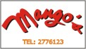
Palmahia
Address: Cra 42 No. 85B-121 (Autopista Sur)
Telephone: 3 62 57 57
Prices Between: 50.000 – 1’200.000
It is the biggest night club in Medellin and Colombia, It has a 3000 people capacity. It has a volleyball court, boxing ring and live dancers. Located near Mangos, and Universal on ‘Autopista Sur’, (Highway South). 10 minutes from El Poblado.
http://www.Palmahia.com
Universal  Cra 42 No 72-125 (Autopista Sur)  Teléfono: 2852020  20.000 peso cover – Free Bar  Live Dancers, Crossover Music, once of the largest clubs  Thurs, Fri  Info 285-3535 | 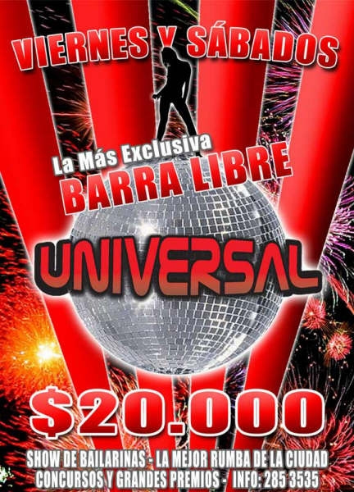

Trilogía Bar
Address: Cra. 43 G N. 24 – 08
Telephone: 262 63 75
Comments: Rock n Roll, Live music, Great alternative to the Techno and Hip Hop. Something different than the typical mixed music dicoteca. A recommended bar for those over 30 or if you like rock n roll.
Macondo
Cover: $ 10.000 pesos
Prices between $ 35.000 and 150.000.
Live singers and Shows. Tropical environment.
Sam Pues  Jueves del la Guyaba  Domingos de festivos  2x1 drinks until 10pm  266 94 04  Cover: $ 10.000  Prices between $ 30.000 and $ 90.000 pesos.  Singers and crossover music. Good for dancing | 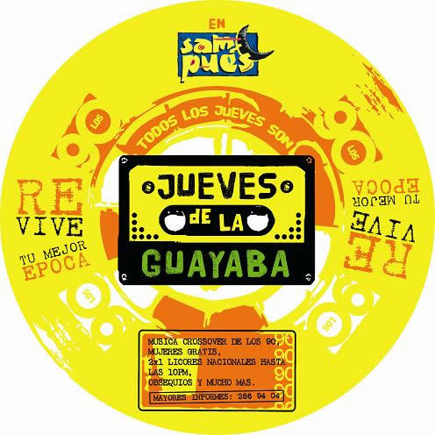

SanthelmoBar
Sabaneta (southern part of Medellin)
Cra. 43ª No. 49 Sur 13
331- 08 67
Santhelmobar@epm.net.co
Vox  bar / restaurant  Cra. 41 No 9 – 22 (Parque Lleras)  Thurs, Fri, Sat  266 21 26  www.bar-vox.com | 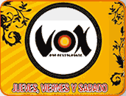

INFORMATION PROVIDED BY:
Paradise Realty & Medellin Tours
www.ParadiseRealtyMedellin.com
Paradise Realty is the Largest
International Property Management
and Rental Realtor in Medellin
WE HAVE OVER 100 MEDELLIN APARTMENT RENTALS
WE ARE THE FASTEST GROWING PROPERTY MANAGEMENT COMPANY
For Parque Lleras Restaurants and Bars please see:
http://www.MedellinApartments.info/restaurants
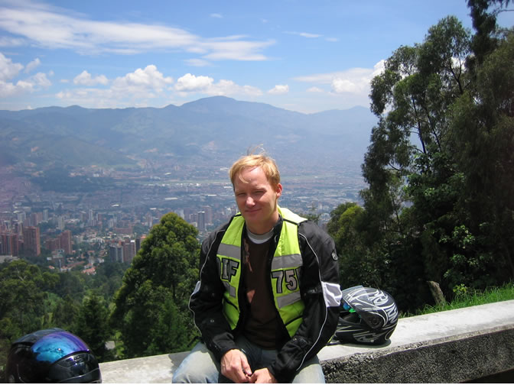
James@ParadiseRealtyMedellin.com
USA Direct 1-415-240-4698
Medellin COLOMBIA Contact Information:
(57) 313-390-7109 Cell for James (English or Spanish)
(57) 320-644-7381 Cell for Adriana (Spanish Only)
(57-4) 581-57-70 Medellin Tours Office
(57-4) 314-20-25 Paradise Realty Office

